**MARVIN B. WARO || BSCS 3B**

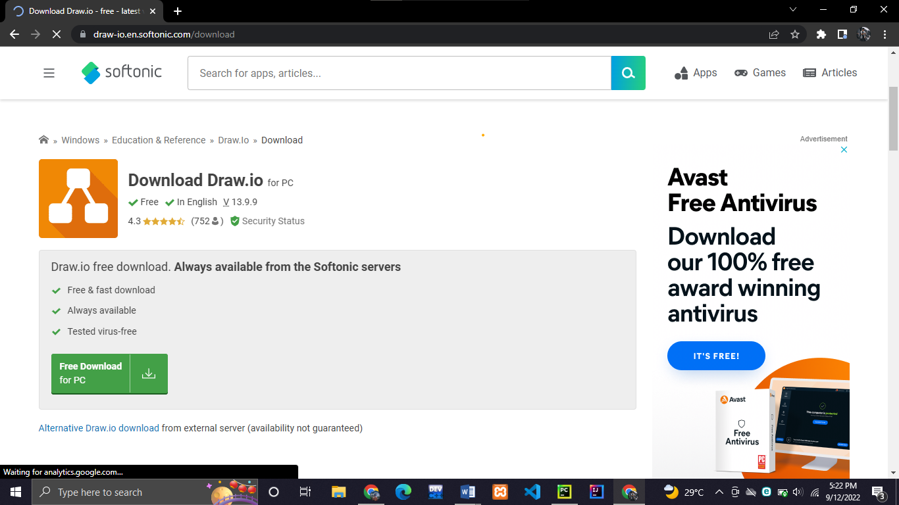**ACTIVITY 1**

1. Downloading Draw.io for flowcharts and diagrams

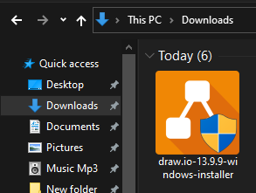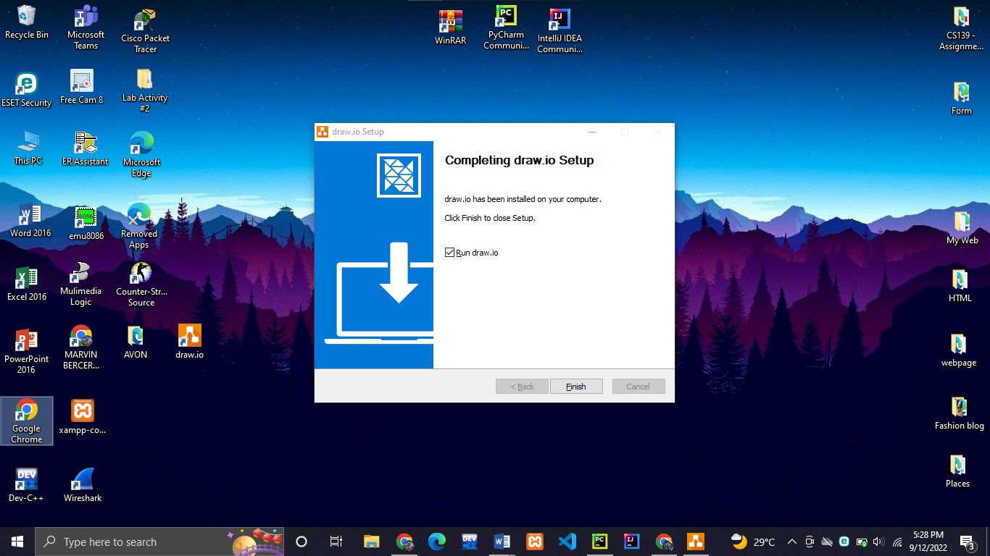

1. XAMPP – for SQL scripting

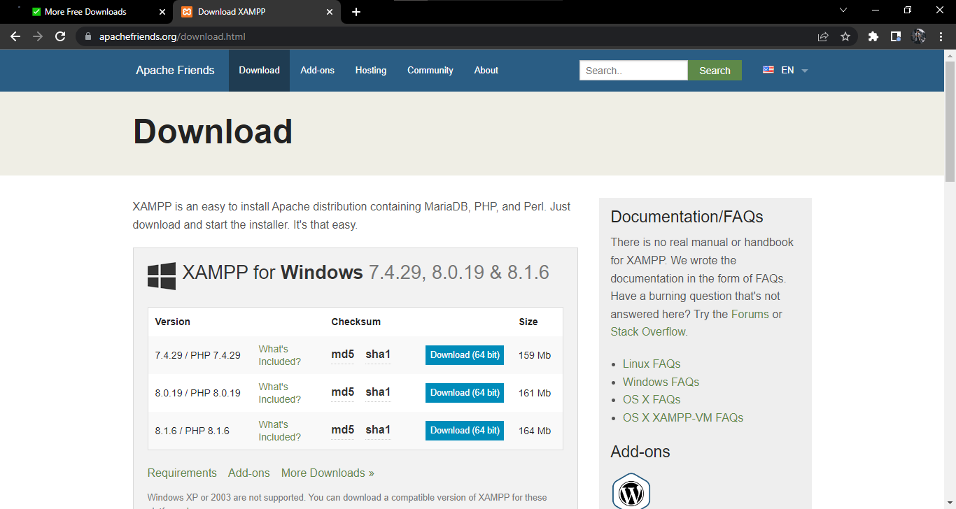

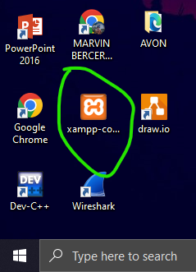I already have a xampp in my desktop which I’ve always use in out information management

1. Github Desktop for Source Code Submission and Presentation

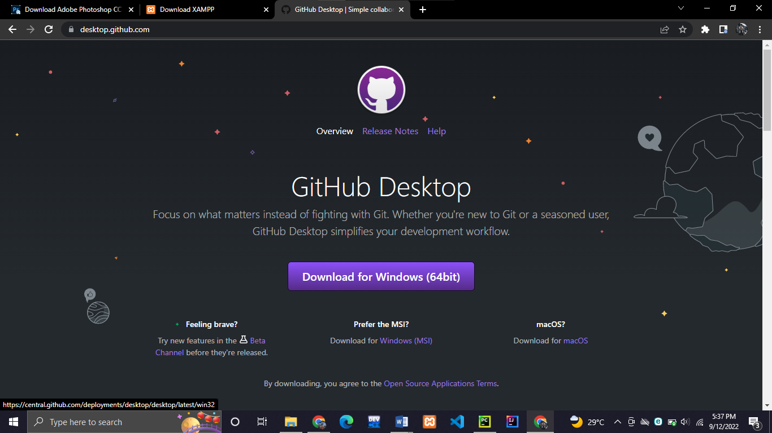

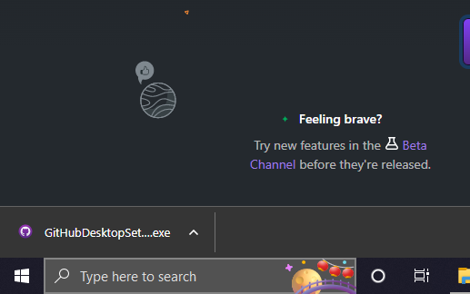

1. (Optional but Highly Recommended) Install VS Code for easier and more flexible programming

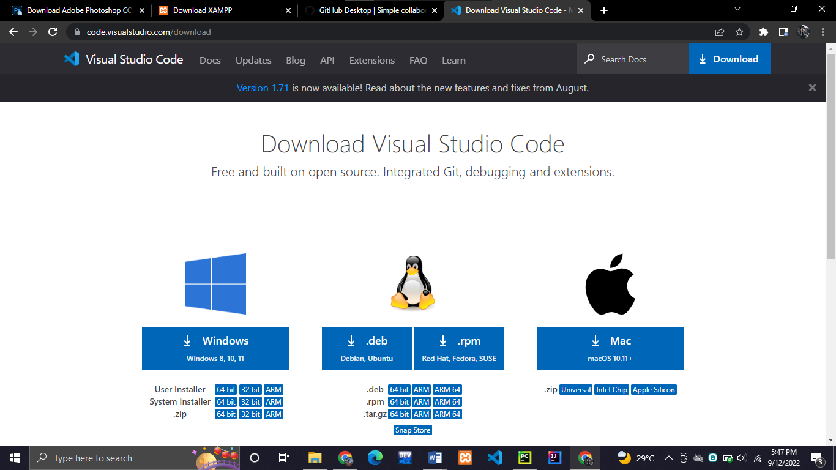

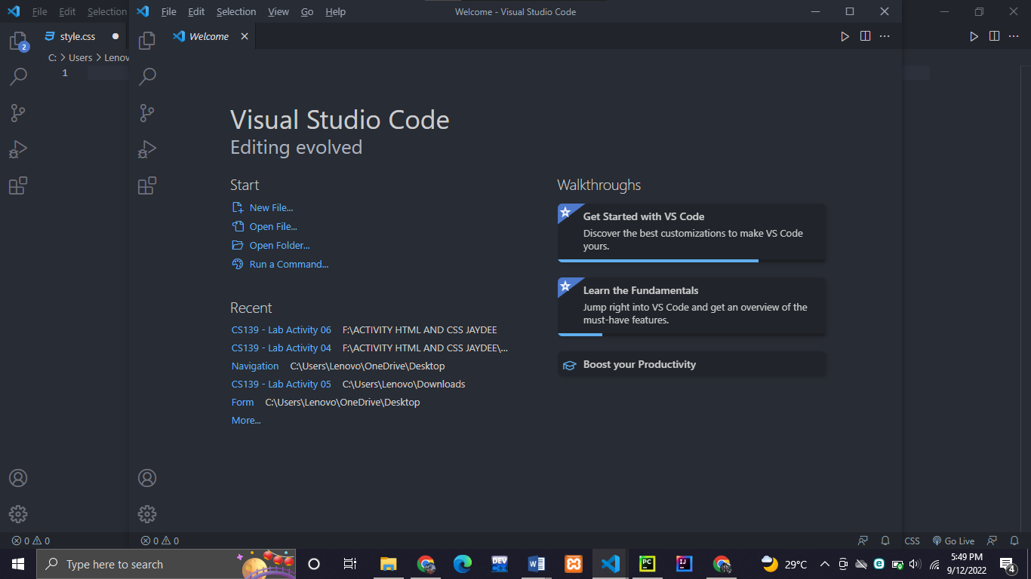

Include the full names of your group mates:

Waro, Marvin B.

Almorfi, Robin Jr. O.

Tan, Kenneth F.